Appendix 2
Loading process description and
general HSE rules for carriers

Table of Contents
1. Description of the loading process 3
1.1 Entrance at the gate 3
1.1.1 Gate entrance (passenger traffic) 3
1.1.2 Registration for loading/filling 3
1.1.3 Entrance at the gate (freight traffic) 4
1.2 Release of products 8
1.2.1 Filling/loading condition, requirements for all isocyanate products 8
1.2.2 TDI products 12
1.2.3 Filling/loading of MDI products 14
1.2.4 OTDA product 17
1.2.5 PVC product 18
1.2.6 TPU product 22
1.2.7 Filling conditions, requirements for chlor-alkali products 26
1.2.8 Filling/loading POLYOL BLENDS 26
1.3 Documentation 28
1.3.1 Gross weight weighing 28
1.3.2 Documentation 28
1.3.3 Customs clearance 28
1.4 Gate exit (at gates 4 and 41) 28
2. General HSE rules 29
2.1.1 General safety requirements 29
2.1.2 Vehicle traffic, transport of materials 30
2.1.3 Characteristics and occurrence of hazardous substances in industrial quantities in BC premises 31
2.1.4 Regulations in case of emergencies 33
2.1.5 Safety inspection 33
2.1.6 Environmental protection regulations 34
2.1.7 Asset protection rules 35
2.1.8 Road traffic regulations in BC 36
2.1.9 Rules on security of property 37
2.1.10 Sanctions table 37
Annex 1 SKETCH MAP OF BC 38

1. Description of the loading process

Entrance at the gate

Gate entrance (passenger traffic)
Drivers must have an access card to enter BC’s area. If the driver is banned from BC for a previous offence, then the drive cannot receive an access card.
Issue of an access card:
The Passenger and freight administrator issues the guest card on the basis of the transport order number and the driver's identity card or passport and the registration certificate of the transport vehicle.
If this is the first time the driver has visited our company, a photo is taken of the person for the access card.
The driver will receive the following documents together with the access card:
- Sketch map of BC (Annex 1),
- a leaflet containing information on safety rules in the appropriate language (not in all cases).
Familiarisation with the content of the information leaflet shall be considered as safety training.
Signposts are posted along the roads.

Registration for loading/filling
Location: Forwarding Office (map)
Before entering by vehicle, the driver in possession of an access card must go on foot to the Forwarding Office, where he will receive a Loading Order as follows.
Required data/documents:
- Freight order / delivery instruction number (SZU number),
- License plate/registration number,
- Valid loading time reservation in the Transwide (TW) system
- a valid ISOPA exam for bulk deliveries (QR code, ISOPA exam certificate is acceptable),
- a valid ADR certificate, if the goods to be transported are subject to ADR,
- access card,
- a valid transport licence for a specific type of transport, the detailed list is available at the following link:
http://www.nkh.gov.hu/documents/11102/545604/Enged%C3%A9lyk%C3%B6telezetts%C3%A9g+2015/c27096ea-df2f-4097-b989-cb46c17bd089?version=1.3&type
Process:
- Verification of the existence of ADR certificate, ISOPA exam, transport licence by the Customs and Documentation Department. In case of deficiency, the BC refuses to issue the loading order!
- The loading order indicates the loading, filling time and location. The driver may enter at freight gate IV taking into account this loading time. (The transport vehicle can enter within ±10 minutes of the indicated loading/filling time!) (t=time-slot)
Chlor-alkali packaging: between t-30 min to t
PU packaging: between t-30 minutes to t
PVC packaging: between t-20 min to t+20 min
Nitric acid - ammonia: between t-30 min and t+30 min
In all other cases: between t-30 minutes to t
- IMPORTANT! The access card is used for weighing! If the card has to be replaced for any reason, only the Customs and Documentation department will be able to assign the new card to the SZU number!

Entrance at the gate (freight traffic)
On entry, the Passenger and freight administrator will provide directions to the weighbridge and the filling/packing plant based on the map provided.
After check-in with the access card, the vehicle can enter. If the vehicle arrives after the time interval specified in 4.1.2, BC will refuse entry, but the Passenger and freight administrator will notify the packaging plant, not to wait for the truck and the driver will return to the Forwarding Office where they will issue a different loading time in their time-slot access control system.
At the time of entrance at the gate, the Personnel and Freight Officer will always check the registration number on the loading order against the vehicle license plate/registration number. If there is a discrepancy, then he will notify the Forwarding Office to reconcile the data.
If the vehicle is arriving for a palletised, piece goods transport, the passenger and Passenger and freight administrator will check the cargo area. If there is material or equipment inside of cargo area, the driver is reminded that after entry, it can only be transported out, if the appropriate document is present.

Checking of personal protective equipment
The driver of the vehicle must be equipped with appropriate personal protective equipment when enters with the vehicle. At the time of entry to the gate, the driver will be checked for a safety helmet, chinstrap, safety glasses, full face mask with filter cartridge, ABEK-CO-NO-Hg-P3 combined filter cartridge.
If the driver is not wearing personal protective equipment, the Passenger and freight administrator will refuse entry of the vehicle.
The presence of special protective equipment required by the technological area is checked by the plant (e.g. rubber boots, rubber gloves, etc.).

TARE Weighing
TARE weighing is always carried out on the automatic weighing equipment at gate IV and on the weighing equipment at gate 41 (map).
When weighing, follow the instructions on the terminal of the weighing equipment!
IMPORTANT! The driver must always check the TARE weighing slip! The weighing slip must include:
- SZU number
- License plate/registration number
- driver's name
- measured weight!
If any data is missing or not correct, driver must contact the Customs and Forwarding Department (Forwarding Office) to resolve the problem!
If the driver is applying for loading/filling with an incorrect weighing slip, the responsible plant will refuse the loading/filling!
Normally, the TARE weighing should be carried out immediately after the entry to the gate, with the transport vehicle still empty.
For certain containers to be loaded onto a cruise ship in the future, it is necessary to determine the total weight of the loaded container.
http://www.worldshipping.org/industry-issues/safety/WSC_Summarizes_the_Basic_Elements_of_the_SOLAS_Container_Weight_Verification_Requirement___January_2015_-3-.pdf
For weighing other than the normal process, TARE weighing is performed with the empty chassis (without container), while Gross weighing is performed with the loaded container.
In such a case, the Forwarding Agent will inform the driver when issuing the loading order!
If the transport vehicle arrives with a container to be loaded, the TARE measurement must be carried out together with the container.
An amendment to the SOLAS (Safety of Life at Sea Convention) adopted by the International Maritime Organisation, or IMO, requires all shippers to provide a certified and written proof of the total weight of the container they are shipping.
SOLAS defines the VGM as Verified Gross Mass
Of the two methods that can be used to determine VGM, BorsodChem intends to use both. The choice of the method depends on the material transported in the container and whether it is transported from BorsodChem after pre-loading or after loading and filling. The responsibility for the choice of the method (1 or 2 methods) of issuing the VGM declaration and the content of its issue rests in all cases with the Rail and Deep-sea Transport and Customs Department. A VGM document is issued for the measurement and sent to the forwarder together with the other documents.
As in previous practice, drivers must always report to the staff of the Rail and Deep-sea Transport and Customs Department before picking up/dropping off containers, who will provide them with further instructions depending on the type of loading.
The type of VGM varies depending on
- the transport vehicle comes for a pre-loaded container,
- is loaded at the plant within the framework of a public way loading,
- goes to road tanker loading - for bulk goods.

1. method: Pick up of a pre-loaded container (VGM 1 declaration)
A: The transport vehicle arrives empty to pick up the loaded container
1. Deep-sea Transport Department Log in to the Deep-sea Transport Department
Data reconciliation
Access card scanning, registration
2. Weighing Weighing with empty chassis (tare weighing)
4. Deep-sea Transport Department Card scanning (sending for gross measurement)
5. Terminal Pick up a loaded container at the terminal.
Receiving documents (packing list) at the terminal.
6. Weighing Weighing with the loaded container (gross weighing)
7. Customs and Documentation Department Handing over documents and card reading at the Customs and Documentation Department
Receipt of completed documents
B: Empty containers are brought down to pick up the loaded container
1. Deep-sea Transport Department Log in to the Deep-sea Transport Department
Data reconciliation
Card scanning, registration
2. Terminal Unloading of empty container(s)
3. Weighing Weighing with empty chassis (tare weighing)
4. Deep-sea Transport Department Card scanning (sending for gross measurement)
5. Terminal Pick up a loaded container at the terminal.
Receiving documents (packing list) at the terminal.
6. Weighing Weighing with the loaded container (gross weighing)
7. Customs and Documentation Department Handing over documents and card reading at the Customs and Documentation Department
Receipt of completed documents.
For the VGM 1 declaration, the weight data are identical to those shown in the DFM programme. The difference between the gross weight on the delivery note and the VGM verified gross weight (the net weight measured on the automatic weighing equipment) gives the container's tare weight. This could be thousands of kilograms. The container is marked with its tare weight.
2. method: Public Road loading of box containers, bulk containers (VGM 2 declaration)
A: Box 20- or 40-foot containerised road loads, in all cases VGM 2 declaration is provided
1. Deep-sea Transport Department Log in to the Deep-sea Transport Department
Data reconciliation
2. Customs and Documentation Department Log in to the Customs and Documentation Department
Issue of a loading order
Card scanning, registration
3. Weighing Weighing with empty container (tare weighing)
4. TDI/MDI/PVC/HPM Plant Loading in the packing plants
Card reading by the plant (sending for gross weighing)
5. Weighing Weighing with the loaded container (gross weighing)
8. Customs and Documentation Department Handing over documents and card reading at the Customs and Documentation Department
Receipt of completed documents.
B: For bulk container shipments, a VGM 2 declaration is always provided
1. Deep-sea Transport Department Log in to the Deep-sea Transport Department
Data reconciliation
2. Customs and Documentation Department Log in to the Customs and Documentation Department
Issue of a loading order
Card scanning, registration
3. Weighing Weighing with empty container (tare weighing)
4. TDI/MDI Packaging Plant Filling at packaging plants
Card reading by the plant (sending for gross weighing)
5. Weighing Weighing with the loaded container (gross weighing)
6. Customs and Documentation Department Handing over documents and card reading at the Customs and Documentation Department
Receipt of completed documents.

On the VGM 2 declaration, the gross weight on the Packing List and Certificate of Analysis form (which is also the gross weight on the delivery note) is entered in the box for the total weight of the load and the container's tare weight is added. The gross weight on the delivery note should be compared with the net weight of the weighing slip note. The weight deviation may vary within the specified interval.
In all cases, the container's tare weight is given by the Rail and Deep-sea Transport Department at the VGM.

Release of products
When loading and transporting isocyanate products, BC complies with the relevant legal requirements and expects full compliance from the carriers applying for loading/filling. In addition to the legal requirements, the tasks related to filling/transportation are also governed by the relevant guidelines and standards, e.g. the ISOPA Directive - to establish a high level of safety for the loading, unloading and storage of toluene diisocyanate (TDI) and diphenylmethane diisocyanate (MDI) - and best practice guidelines, e.g. "European Best Practice Guidelines on Cargo Securing for Road Transport" will be used by BC.
The BC aims to take all precautions to ensure the safety of participants during the loading/unloading operation and during transport.

Filling/loading condition, requirements for all isocyanate products

Filling into tanker/container
The means of transport must be suitable for the transport, the product to be transported must be loaded and it must comply with the relevant legislation and quality parameters.
The tanks, dome cover, associated hoses, fittings must be clean, dry and odourless, and the external seals must be free of dirt and intact. The place of loading reserves the right to refuse to load the means of transport if it considers that its condition poses a risk of contamination of the product or a dangerous chemical risk.
Adequate and approved cleaning stations must be used for cleaning the means of transport and written documentation of cleaning and drying must be provided to the point of loading on request.
The product can be loaded at the predefined time. Failure to do so may result in a delay/waiting time at the actual loading time, for which the filling station cannot be held responsible.
At check-in, the operator is required to check that the vehicle arriving for loading has weighed in on the automatic weighing equipment and that the tare weight is sufficient for loading/unloading. If the initial weighing is not met, the truck must be sent back for weighing.

Before filling, the tank/tank container is checked by the filling point operator:
- its capacity is appropriate for the quantity to be loaded.
- whether its armatures are in a satisfactory technical condition,
- all the individual equipment (heater, compressor, etc.) is in good working order,
- the inscriptions on the nozzles, which should be on an engraved plate as close as possible to the coupling (The language used on the engraved plates should be at least English),
- all connections shall be secured by a blind flange or protective cap and a suitable sealing ring or other system offering equivalent protection (dry joint),
- whether the closing elements are fitted with the correct gasket and the required number of screws and are in a closed condition,
- the driver must have the necessary seals for the connections of the tank-vehicle/tank-container.
The filling station will refuse to fill if the above requirements are not met and considers that there is a dangerous risk during filling and transport.
In the case of products containing dangerous substances covered by the ADR, if the container/ tank container does not comply with the minimum applicable legal requirements or if there is a safety risk when filling, the filling point will refuse the filling, e.g. in the case of vehicles transporting products for food or pharmaceutical purposes.
In the case of products containing dangerous substances covered by the ADR, it is checked by the operator after notification:
- it is provided with ADR hazard signs and labelling appropriate to the product to be transported,
- the presence of the necessary ADR equipment:
  - one wheel chock for each vehicle, of a size corresponding to the maximum permissible loaded weight of the vehicle and the diameter of the wheels.
  - two warning signs stopping on their own
  - eye rinsing liquid
  - reflective vest
  - portable lighting device
  - fire extinguisher corresponding to the total weight of the transport unit, first-aid kit
  - a suitable eye protection device (e.g. safety goggles)
  - a pair of protective gloves
- Other personal protective equipment mandatory in BorsodChem
  - gas mask with filter cartridge (ABEK CO NO Hg P3)
In case of any deficiency, the filling station will refuse to fill.

Any problems that arise during the filling process, the collection of any spillage and rescue operations are handled by the filling point operator according to BC's internal procedures. In the event of a malfunction in the PU Packing area, the driver must follow the instructions of the filling station operator.
In the case of products containing dangerous substances covered by the ADR, if more than 1 dl of product is released into the environment, e.g. from the dome cap of a tank container/tanker, it must be treated as a "Loading incident" and reported and documented to the filling point personnel in all cases. A record of the incident is made and must be signed by the driver.
During transport, the driver must maintain the temperature of the product within the temperature range specified on the issued Transport Order or CMR.
After unloading, the transport equipment must be flushed with nitrogen and kept at the temperature appropriate for the material transported, as the minimum product remaining in it may be damaged.

Loading of products into drums and IBCs
When securing products in drums or IBCs to the transport vehicle, the relevant regulations and standards must be observed (e.g. DIN EN 12195-2, DIN EN 12640, DIN EN 12642). See also ECTA - Cefic guidelines for securing loads in road freight transport.
Minimum requirements for load securing devices:
- A sufficient number of unbroken tie straps for each pallet latch according to the standards mentioned above.
- Unbroken and sufficient anchorage point according to the above-mentioned DIN standard for each pallet latch.
- Use of anti-slip mats, depending on the loading area/product.
- Only ratchet straps, ropes and other tie-down devices that have been tested and are in good condition may be used.
In all cases, the most appropriate method of securing should be used, appropriate to the characteristics of the transport vehicle and the load. When transporting IBC goods, the use of anti-skid devices is mandatory. The loading bay reserves the right to refuse a delivery vehicle arriving without an anti-skid device when loading products in an IBC.
Examples of load securing devices:

Anti-slip devices:
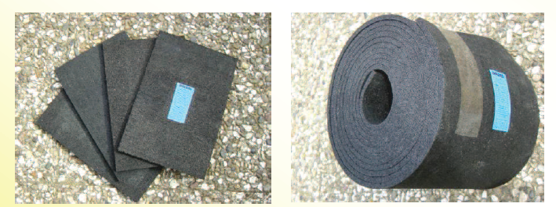

Ratchet straps: With short- or long handle.


Cargo bars and load lock bars:
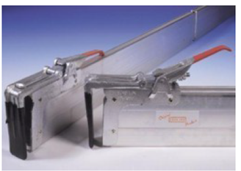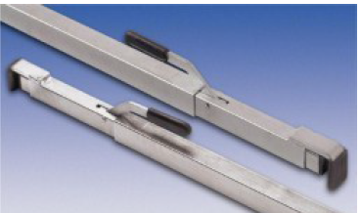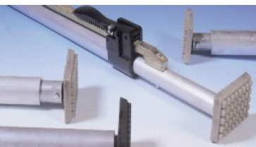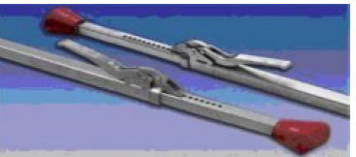
for lorries with tarpaulin or rigid walls, refrigerated vehicles

Guard bead protection equipment:
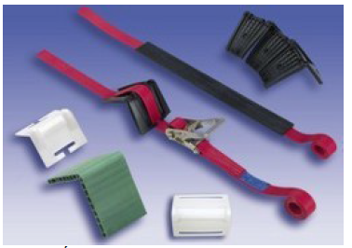
Example of load securing for barrel and IBC cargos:
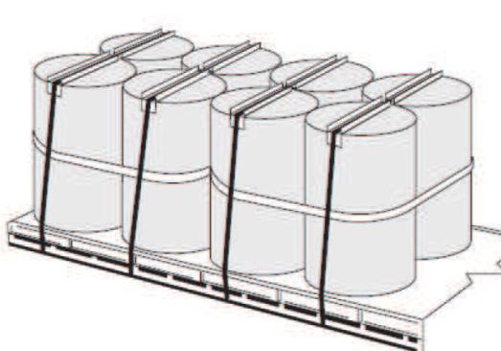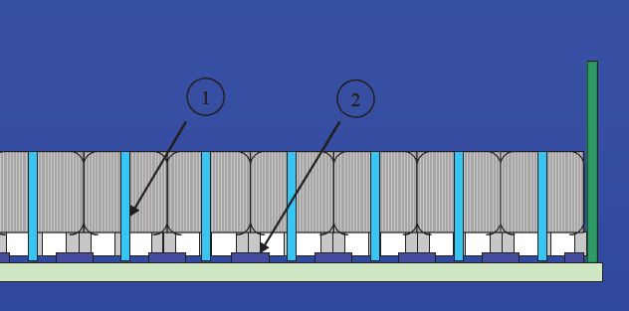
The primary practical condition for the use of the support equipment is that the vehicle and its load compartment must be designed to meet the requirements for the use of the above equipment.
When loading/unloading products covered by the ADR, full compliance with the relevant regulations is required for both equipment and documentation.

Requirements for drivers:
- For bulk transport of isocyanates, possession of an ISOPA training certificate.
- Communication with the filling station staff at the loading/unloading site is essential. In the case of hazardous materials, it is a strict safety requirement for the driver to understand the instructions of the filling station staff.
- Have the necessary personal protective equipment required at the filling point. When present at the filling station, you must wear: a protective helmet with chinstrap, safety goggles, closed protective clothing (flame retardant, antistatic, chemical resistant) and protective footwear and a full-face mask with filter cartridge, with ABEK-CO-NO-Hg-P3 combined filter cartridge. In addition, when bulk filling MDI products, the wearing of overalls to protect against splashing liquids is mandatory during connection and disconnection work (e.g.: Microgard 1500+, Microchem 3000, 4000, Tychem F, Kleenguard T35) and closed safety goggles.
- If the driver is not wearing the required personal protective equipment, the filling station will refuse to fill the tank.
- Appearance in working order. In order to avoid an accident, no loading/unloading should take place if it is obvious that the driver is: under the influence of alcohol, drugs or narcotics.
- Safe and responsible behaviour.
- As with most companies, BorsodChem Zrt. has internal rules designed to protect the safety of employees and visitors, and these rules must be followed.
  - Follow the procedures and warning signs in place.
  - Observe the maximum speed limits.
  - Follow the routes described.
  - Follow the instructions of the company/location staff.

TDI products
TDI products are dispensed from the TDI Packaging area. To release a product, the driver must check in at the foreman's office. Filling and loading operations are supervised by the foreman, the deputy foreman or the headmaster foreman.
It is checked separately by the filling station staff before filling starts:
- whether the vehicle is fitted with ADR danger signs:
  - with the big label 6.1 and numbered yellow plates (UN no: 2078, hazard number: 60).

- in the case of a tank container, in addition to the danger signs, also with the inscription (toluene diisocyanate).
The filling station will refuse to fill if the above requirements are not met.
At check-in, the operator is required to check that the vehicle arriving for loading has weighed in on the automatic weighing equipment and that the tare weight is sufficient for loading/filling. If the initial weighing is not met, the truck must be sent back for weighing.

The driver takes part in the TDI charging as follows
- The driver must park in the parking space designated for him, wearing the personal protective equipment necessary for loading, report to the foreman for loading, hand over the "Loading order".
- When instructed by the filling station employee, drive the vehicle onto the designated weighing equipment. If a mobile STOP sign has been placed in front of the weighing equipment, the driver may only drive on the weighing equipment after the STOP sign has been removed! The management of the mobile STOP sign is the responsibility of the filling station system operator. If at the weighing equipment has an indicator light, the driver may only drive onto that weighing equipment when the light is green.
- During filling, the mobile STOP sign is reset and the traffic light turns red.
- The tractor of the vehicle combination must be stopped by the driver on the weighbridge when loading starts, the vehicle combination must be earthed and secured against movement and wedged. At the time of weighing and filling, the driver must leave the vehicle and the filling area and hand over to the filling station foreman the vehicle start key, which is kept in a suitable and safe place until the filling is completed.
- The connection and disconnection of the tanker/tank container to the filling system is carried out by the filling point operator. The driver must wait in the drivers' lounge during the loading.
- The filling of the tanker/tank container is considered complete when the final weighing has been carried out after filling, the filling point operators have disconnected the filling and gas discharge lines and the tipping stair has been raised.
- At the end of the filling operation, the filling station staff will document the release of the product, hand over the necessary documents to the driver and return the vehicle start key to the driver.
- After filling is complete, the driver must remove the wheel chocks from under the vehicle combination and disconnect the earthing cable from the vehicle combination. Once the driver received permission from the staff at the filling point to drive off, or the light has turned green or the mobile STOP sign has been removed, the driver can drive off the weighbridge. When the traffic light is red, it is forbidden to drive off!
- The delivery vehicle may leave the filling station area.

Loading of TDI products in drums
- Before loading starts, the loading bay checks that the transport vehicle is equipped with protection against longitudinal displacement of the load. If the transport vehicle does not have such protection, loading cannot begin.
- At the end of the loading, the operators of the loading bay take a photograph of the cargo to document the tie-down of the cargo.
- Securing devices must be available in the quantity and quality appropriate to the design of the transport vehicle and the load.
- The driver must secure the load in such a way that it cannot move during transport.
- The forklift truck driver distributes the load on the vehicle according to the driver's instructions, hereinafter the driver is responsible for the safe arrangement and securing of the load, which he confirms by signing when taking over the load.
- The Packing List documents may be handed over to the driver only after the load has been secured. In the event of non-anchoring or inadequate anchoring of the load, handing over the Packing List documents shall be refused until the proper anchoring of the load has been made.

Filling/loading of MDI products
MDI products are dispensed from the MDI Packaging area. Except for Ongronat 2100 products in containers or barrels, which are filled/loaded from the TDI/MDI Packaging area.
To release a product, the driver must check in at the foreman's office. The foreman or headmaster foreman is in charge of the filling or loading operations.
The driver must heat the tank according to the type of material to be loaded:
- For polymer MDI min. 12°C max. 30°C
- For modified MDI min. 35°C max. 45°C
- For monomer MDI min. 42°C max. 45°C (also for Ongronat XP-1151)
- For prepolymers and MDI variants min. 30°C max 50°C
It will be checked by the filling station staff before filling starts:
- whether the vehicle is fitted with ADR danger signs:
For variant products containing TDI and Ongronat TR 4001/TR 4011
with the big label 6.1 and numbered yellow plates (UN no: 2206, hazard number: 60).
The filling station will refuse to fill if the above requirements are not met.
At check-in, the operator is required to check that the vehicle arriving for loading has weighed in on the automatic weighing equipment and that the tare weight is sufficient for loading/filling. If the initial weighing is not met, the truck must be sent back for weighing.

The driver participates in the MDI filling as detailed below
- The driver must park in the designated parking space, wear the required protective equipment and report for filling to the foreman, handing over the "Loading Order".
- If instructed by the filling point operator, drive the vehicle combination to the designated filling point. If there is a mobile STOP sign in front of the filling point, driver must not drive onto the filling point until the sign has been removed! The management of the mobile STOP sign is the responsibility of the filling station operator. The mobile STOP sign will be reinstalled during the filling operation. The removal of the sign must be clearly indicated to the driver by the filling station operator.
- The towing vehicle of the vehicle combination must be stopped by the driver on the filling station when filling starts, the vehicle combination must be earthed and secured against movement and wedged.
- The driver will then carry out the following operations to connect the tanker/tank container:
  - Wearing a coverall is compulsory when attaching and detaching and must be worn on and with the work clothing. During filling of Ongronat TR 4001/TR 4011 products, the use of a full-face mask with ABEK combined filter insert is mandatory.
  - First, the gas hose is connected to the transport device, then a common air space is created between the gas compartments of the tanker/tank container and the product storage tanks by opening the gas branch fittings. This operation should always be performed first, as it ensures that the nitrogen remaining in the tanker/tank container from the previous discharge is released to the MDI storage tanks. After this operation has been carried out, the gas branch fittings shall remain open for the pressure test to be carried out before the filling operation and, of course, during the filling operation. Do NOT remove the closing element from the siphon pipe of a transport vehicle under nitrogen pressure!
  - After the nitrogen pressure has been released, only remove the sealing element from the liquid branch! The transport vehicle may be connected by quick couplings if the transport vehicle is equipped with the appropriate counterparts, or, in their absence, with flange couplings.
  - The connection must be made by the driver only with for MDI specified, damage-proof seals. The driver must have the necessary seals for the tanker/tank container connections.
  - Quick couplings, flange joints must be connected with adequate tightness. Any problems with either the seal or the connection should be reported immediately to the operator/foreman who will take care of the problem. No leaks must occur during filling, this must be checked with a nitrogen pressure test after connection before filling!
  - If the driver exits the tanker on top of the tanker into an area outside the guardrail on the filling bridge or has to raise the guardrail on the tanker, he must use the anti-fall system installed. Failure to do so will result in a PROHIBITION against any activity or movement on these parts of the tanker.
  - After equalising the pressure, the tightness of the connection is checked with nitrogen at 3 bar. Open the manual nitrogen fitting in the filling pipe, the closing fitting on the siphon pipe is closed. If the connection is tight, close the manual nitrogen fitting, open the closing fitting mounted on the siphon pipe of the tanker/tank container. Then make sure that the siphon pipe is permeable, this must always be done before starting the filling!
  - The operator of the filling station checks the pressure test and the permeability of the siphon pipe. Once the permeability is verified, the DN20 manual fitting shall be closed.
  - When the vehicle assembly has been connected, the pressure test has been carried out and is satisfactory, and the siphon pipe is permeable, the driver reports the vehicle ready for filling status. The filling station operator starts filling the tanker/tank container.
  - After starting the filling process, the driver checks the tightness of the system. Report any leaks detected to the Filling station staff. In this case, the filling must be stopped immediately and the fault must be rectified immediately.
- At the time of weighing and filling, the driver must leave the vehicle and the filling area and, on special request, hand over to the Packaging foreman the vehicle starter key, which is kept in a suitable and secure place until the filling is completed.
- In order to minimise the release of MDI vapours and to avoid spillage, the filling nozzle should be blown through the filling pipe towards the transport vehicle for a few minutes with 3 bar nitrogen before disconnecting the connections. After closing the fittings, the driver shall disconnect the tanker/tank container from the filling station, fit the appropriate closing flanges to the tanker/tank container and to the filling and gas hose couplings.
- The driver of the vehicle must provide the required number of service locks.
- All domes in the space used for transport must be locked with a plant lock issued by the plant.
- The driver must remove the wheel chocks from under the vehicle combination and remove the earthing cable from the vehicle combination.
- After the filling has been completed, the filling station staff will hand over the necessary documents to the driver. Once the driver received permission from the staff at the filling station to drive off or the mobile STOP sign has been removed, driver may drive off the weighbridge. The removal of the sign must be clearly indicated to the driver by the filling station operator, as the sign is not or only with difficulty visible from the cab.
- The delivery vehicle may leave the filling station area.

MDI loading
- Before loading starts, the loading bay checks that the transport vehicle is equipped with protection against longitudinal displacement of the load. If the transport vehicle does not have such protection, loading cannot begin.
- At the end of the loading, the operators of the loading bay take a photograph of the cargo to document the tie-down of the cargo.
- Securing devices must be available in the quantity and quality appropriate to the design of the transport vehicle and the load.
- The driver must secure the load in such a way that it cannot move during transport.
- The forklift driver is responsible for distributing the load on the vehicle according to the driver's instructions, and hereinafter the driver is responsible for the safe arrangement and securing of the load, which he confirms by signing when accepting the load.
- The Packing List documents may be handed over to the driver only after the load has been secured. In the event of non-anchoring or inadequate anchoring of the load, handing over the Packing List documents shall be refused until the proper anchoring of the load has been made.

MDI loading in the Cold Drum Storage
The Cold Drum Storage is used to release pure MDI products in drums (Ongronat 3000/3020/3050 etc.) in frozen state. Vehicles reporting for loading must have a temperature register, which is checked by the loading bay staff.
- Before loading starts, the loading bay checks that the transport vehicle is equipped with protection against longitudinal displacement of the load. If the transport vehicle does not have such protection, loading cannot begin.
- At the end of the loading, a photograph is taken to document the anchoring of the cargo.
- Securing devices must be available in the quantity and quality appropriate to the design of the transport vehicle and the load.
- The driver must secure the load in such a way that it cannot move during transport.
- The forklift truck driver distributes the load on the vehicle according to the driver's instructions, hereinafter the driver is responsible for the safe arrangement and anchoring of the load.
- The vehicle can be loaded on the ramp by lowering the rear wall.
- Do not block the traffic route during loading.

OTDA product
The driver has to report to the TDI packaging foreman's office to release the product, and the foreman or headmaster foreman in charge is responsible for the filling or loading operations.
The vehicle is escorted to the product filling point by the staff of the filling station.
The filling/loading station will only start filling/loading if the driver has entered the premises wearing the appropriate protective equipment.
It will be checked by the filling station staff before filling starts:
- whether the vehicle is fitted with ADR danger signs:
  - with a large label for 9 classes
  - UN number: 3257
  - Hazard number: 99
  - Environmentally hazardous substance symbol
- in the case of a tank container, in addition to the danger signs, the following inscriptions:
ELEVATED TEMPERATURE LIQUID, N.O.S.
(3(or 4)-methylbenzene-1,2-diamine) F-A, S-F
- The material of the seals must be appropriate to the temperature of the filled material.

The filling station will refuse to fill if the above requirements are not met and considers that there is a dangerous risk during filling and transport.

The driver participates in OTDA filling as detailed below
- The driver must park in the designated parking space, collect his personal protective equipment and report to the foreman for filling, hand over the "Loading order".
- If instructed by the filling point operator, the driver shall drive the vehicle combination to the designated filling point.
- The towing vehicle of the vehicle combination must be stopped by the driver on the filling station, when filling starts, the vehicle combination must be earthed and secured against movement and wedged. During the filling, the driver must leave the vehicle and the filling point.
- The connection and disconnection of the tanker/tank container to the filling system is carried out by the locksmiths of the plant in the presence of the filling station system operators. The driver must wait next to the vehicle during the filling.
- Filling of the tanker/tank container is considered complete when, after filling, the filling and gas discharge lines have been disconnected and the tipping stair has been raised.
- When the filling is completed, the driver must remove the wedges from under the vehicle combination and disconnect the earthing cable from the vehicle combination. At the end of the filling operation, the filling station staff will document the release of the product and hand over the necessary documents to the driver.
- The delivery vehicle may leave the filling station area.

PVC product

Bulk delivery by road tanker
Deliveries are made via a time-slot access system. Truck drivers who come to pick up goods report to the freight forwarding office for loading. Truck drivers identified at the freight forwarder will receive a loading order stating:
- Delivery place
- Order number
- Delivery instruction number
- Buyer name/country
- Vehicle license plate/registration number
- Driver name
- Product name
- Method of packaging
- Quantity
- Quality
- Other provisions
- Name of issuer
- Date and time of issue
On the loading provision is manually entered at the forwarding office the loading time that the driver received in the time-slot access control system.
The vehicle must arrive at the filling station by this time.
If the bulk filling station operator encounters a vehicle driver at the bulk filling station who arrives for filling goods and is not wearing the minimum protective equipment required for vehicle drivers entering our premises, he must stop the driver, call his attention to this and return him to his vehicle to put on the protective equipment and must notify the foreman.
The bulk filling station operator identifies the incoming silo tankers by the license plate/registration number and by the loading order.
To prevent the contamination of PVC powders, the bulk filling station operator must comply with the following rules:
- The driver of the silo tanker may only open the hatch covers of incoming silo tanker at the filling station after the opening measurement has been carried out. It is FORBIDDEN to open the lids of the filling openings before the vehicle reaches the covered filling station.
- Only as many filling openings can be opened as are absolutely necessary to fill the silo tanker.
Before loading, all silo tankers must be checked against the checklist of criteria in the document "Logbook/Protocol ".
To be checked for tankers:
- Tanker interior is clean
- Existence, integrity of the customs seal
- The tanker exterior, for cleanliness.
The bulk filling station operator fills the correct type, quantity, and quality of PVC powder into the silo tanker identified by the license plate/registration number and delivery instruction number (SZU number) using the company's weighing program.
When carrying out the opening and final weighing, the vehicle must have all its wheels on the weighbridge. If the bulk filling station operator notices a discrepancy between the usual tare and the gross weights, he personally verifies the position of the vehicle on the weighbridge.
The bulk filling station operator prints out 4 copies of the weighing slip after the final weighing and locks the silo tanker by placing the plant locks. The drivers then take the weighing slip, loading order and the "Logbook/Protocol" to the foreman, who prints out the plant documents required for the delivery.
Filling of road tanker can be performed at 3 locations at GS2, GS3 and GS4 weighbridge by gravity and fluid channel filling. On the GS 3 weighbridge, conventional pneumatic filling is also possible.
Whether the filling is gravity or pneumatic is determined by the volume of storage silos available at the time or by individual customer requirements.
Required minimum protective equipment:
- head protection helmet EN 397,
- chinstrap,
- closed working clothing,
- closed protective footwear,
- safety googles against mechanical hazards EN 166:2001,
- body harness EN 358, EN 361
- anti-fall harness EN 360-2002
- respiratory protection ready for use: full face mask EN 136:1988, ABEK-CO-NO-HG P3 filter cartridge

Loading of vehicles, delivery by road transport
Deliveries are made via a time-slot access control system. Truck drivers who come to pick up goods report to the freight forwarding office for loading. Truck drivers identified at the freight forwarder will receive a loading order stating:
  - Delivery place
  - Order number
  - Delivery instruction number
  - Buyer name/ country
  - Vehicle license plate/registration number
  - Driver name
  - Product name
  - Method of packaging
  - Quantity
  - Quality
  - Other provisions
  - Name of issuer
  - Date and time of issue
On the loading provision is manually entered at the forwarding office the loading time that the driver received in the time-slot access control system. The vehicle must arrive at the loading station by this time.
Incoming vehicles must be weighed before loading. Vehicles arriving for palletized or Big-Bag goods are weighed at the checking weighbridges at Gate IV.
Incoming vehicles are received and loaded by the forklift truck driver designated at the beginning of the shift with the goods indicated on the loading order.
Before loading, the forklift truck driver checks the empty weight of the vehicle on the loading order measured on the weighbridge before loading. He adds the expected gross weight of the goods to be loaded. If the sum of the two weights exceeds 40 000 kg, he shall notify the foreman and follow his instructions. (Vehicle weighing more than 40 000 kg must not leave the company's premises unless it has a valid route permit.)
Before loading, all vehicles must be checked against the checklist in the document "Logbook/Protocol".
To be checked for trucks with tarpaulin:
  - The integrity of the tarpaulin
  - Existence, integrity of the customs seal
  - Quality of riveting
  - Loading surface integrity
  - Existence of ratchet straps
If the forklift truck driver notices any deficiencies during the condition survey, he shall immediately inform his foreman.

If a forklift truck driver on the ramp or in the warehouse encounters a vehicle driver picking up goods who is not wearing the minimum protective equipment required for truck drivers entering our premises, he must stop, call his attention to this and return to his vehicle to put on the protective equipment and notify his foreman.

The forklift truck driver must check that the truck is secured against movement with a wedge before loading. The loading cannot be started until the anti-slip anchoring is not secured.
If the forklift truck driver observes during loading that the vehicle driver is not wearing the protective equipment, the loading must be suspended, the vehicle driver's attention must be drawn to the wearing of the protective equipment and the foreman must be informed.
After the vehicles have been checked, the palletized and Big Bag packed PVC powders are loaded into the vehicle according to the card storage order.
Before loading, the forklift truck driver agrees the quantities to be loaded and the CH numbers with the foreman.
After the loading, the forklift truck driver writes the loaded CH numbers on the loading order, takes a photo of the vehicle - a separate photo of the load and a separate photo of the license plate/registration number (4-5 photos of one vehicle).

Properly stacked Big Bags and palettized PVC powder packs:

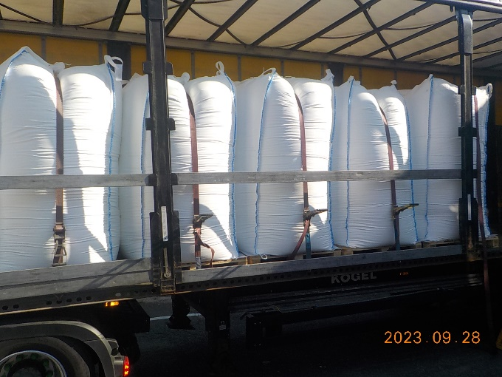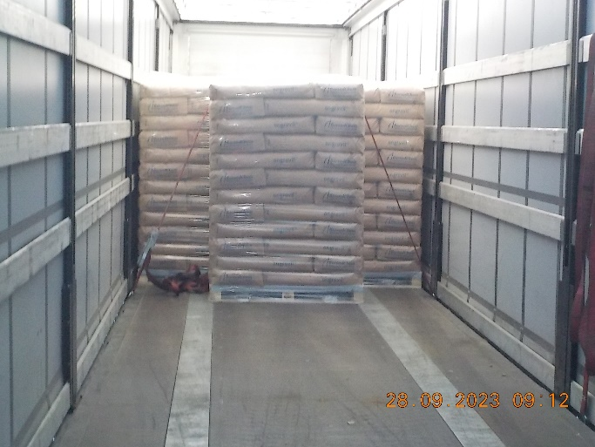

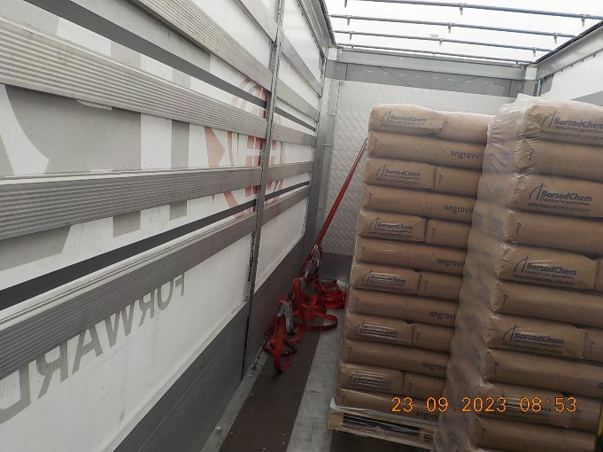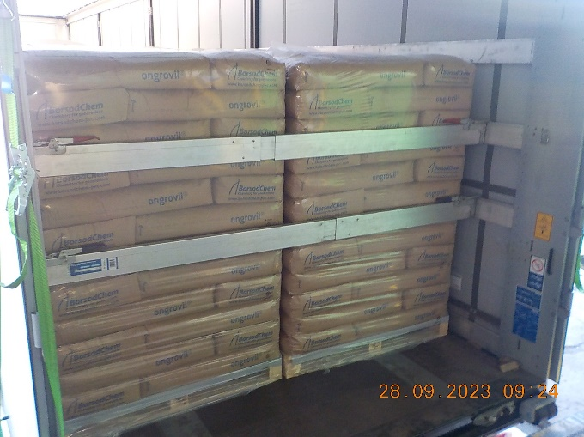

The forklift truck driver then has the vehicle driver sign a document called the "Logbook/Protocol".
The vehicle driver goes to the foreman's office with the loading order and the document called the Logbook/Protocol. The foreman carries out the registration of the loaded vehicle in the SAP system according to the loading order, prints the Quality Control Certificate (MEO) document and the parts counting list, and then hands over the documents required for the documentation to the vehicle driver.
The forklift truck driver (except for domestic deliveries) then places the plant locks on the vehicle.
The vehicle leaves the plant and is weighed at the weighbridge at Gate IV.

Loading of vehicles with unit loads may only be done from a ramp.
Side loading is only allowed for low platform vehicles with a platform height less than the height of the ramp, or if the load capacity of the vehicle does not allow the forklift to be driven on it.
it is FORBIDDEN to load from the side with an 800 mm long fork!
During loading, the road No. 4 must be left free!
Unloading of vehicles (pallet deliveries, etc.) is only allowed from road No. 4 to the loading area or ramp. In this case, road No. 4 must also be left free!
If road No. 4 has to be crossed with a forklift truck at the ramp exit or from the loading area, priority must be given to traffic here.
The speed limit for vehicles on loading bay route on road No.4 is 5 km/h.
The provision of protective equipment is the responsibility of the transport companies!
Subcontractors must have special protective equipment and clothing specified for the transport company. The transport company is responsible for ensuring that protective clothing and equipment is available and that it is used for its intended purpose.
Required minimum protective equipment:
- head protection helmet EN 397,
- chinstrap,
- closed working clothing,
- closed protective footwear,
- safety googles against mechanical hazards EN 166:2001,
- respiratory protection ready for use: full face mask EN 136:1988, ABEK-CO-NO-HG P3 filter cartridge

TPU product

Loading of vehicles, delivery by road transport
Deliveries are made via a time-slot access control system. Vehicle drivers who come to pick up goods report to the freight forwarding office for loading. Loading is possible from Monday to Friday between 7:00 and 14:00.
Vehicle drivers identified at the freight forwarder will receive a loading order stating:
  - Place of delivery
  - Order number
  - Delivery instruction number
  - Buyer name/ country
  - Vehicle license plate/registration number
  - Driver name
  - Product name
  - Method of packaging
  - Quantity
  - Quality
  - Other provisions
  - Name of issuer
  - Date and time of issue
On the loading provision is manually entered at the forwarding office the loading time that the driver received in the time-slot access control system. The vehicle must arrive at the loading station by this time.
Incoming vehicles must be weighed before loading. Vehicles arriving for palletised goods are weighed at the check weighbridges at Gate 41.
Incoming vehicles are received by the person responsible for coordinating the logistics activity or, in his/her absence, by the person designated for this purpose.
According to the data in the SAP logistics module, the day's deliveries should be prepared at least the day before to ensure smooth deliveries. Based on the loading order, the forklift truck operator checks the prepared pallets and then, using the available radio frequency (RF) equipment, links the pallet labels to the loading order in preparation for the material issue accounting.
During loading, the forklift truck operator takes photographs with the RF device, showing the type of load, the charge number of goods and how the load is secured. Photos are automatically uploaded under the SZU number.
Loading of vehicles with unit loads may only be done from a ramp.
Only one row high should be loaded on the vehicle in the case of a vehicle with tarpaulin. In the case of a container or fixed sidewall vehicle, it is possible to use two rows high for pallets up to 500 kg and 750 kg, in which case the use of an intermediate sheet is mandatory! In the case of FCA parity, the buyer is responsible for the intermediate sheets, failing which the factory staff may refuse loading. Any damaged pallet (bag/box/ pallet) during loading must be replaced. Only undamaged cargo may be placed on the transport vehicle.
Loading and load distribution on the vehicle must be carried out in accordance with the driver's instructions.
Before loading, the forklift truck driver must check that the transport vehicle is equipped with the necessary load securing devices to secure the load. If necessary, carpentry shall be used to properly secure the load.
If the transport vehicle is equipped with the necessary means to secure the cargo, loading can begin.
At the end of loading, the load must be secured against shifting.
The locked transport vehicle must be fitted with a numbered plant lock.
The person in charge of coordinating the logistics activity prints out the Quality Control Certificate (MEO) document (3 copies) and the parts count list (3 copies) and gives 2 copies to the vehicle driver, which are necessary for the documentation.
The vehicle leaves the plant and is weighed at weighbridge at Gate 41.

Vehicles that can be loaded at the HPM Plant:
  - 20/40-foot containers
  - light construction and rigid sidewall road transport vehicles

Required minimum protective equipment:
- head protection helmet EN 397,
- chinstrap,
- closed working clothing,
- closed protective footwear,
- safety googles against mechanical hazards EN 166:2001,
- respiratory protection ready for use: full face mask EN 136:1988, ABEK-CO-NO-HG P3 filter cartridge

If a forklift truck driver on the ramp or in the warehouse encounters a vehicle driver picking up goods who is not wearing the minimum protective equipment required for truck drivers entering our premises, he must stop, call his attention to this and return to his vehicle to put on the protective equipment and notify his foreman.

Properly stacked palettized TPU stacks:

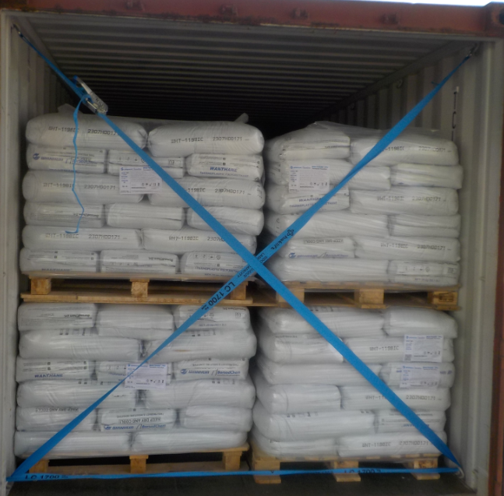
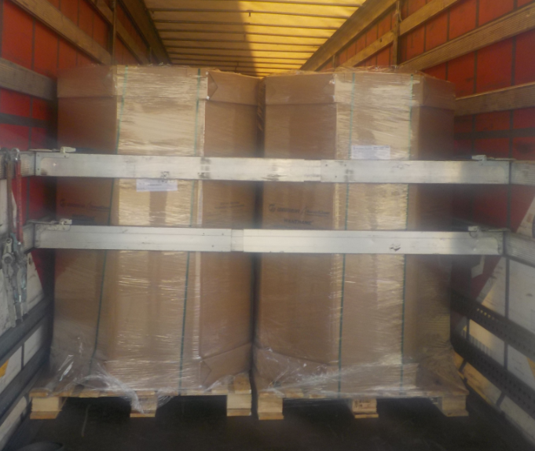

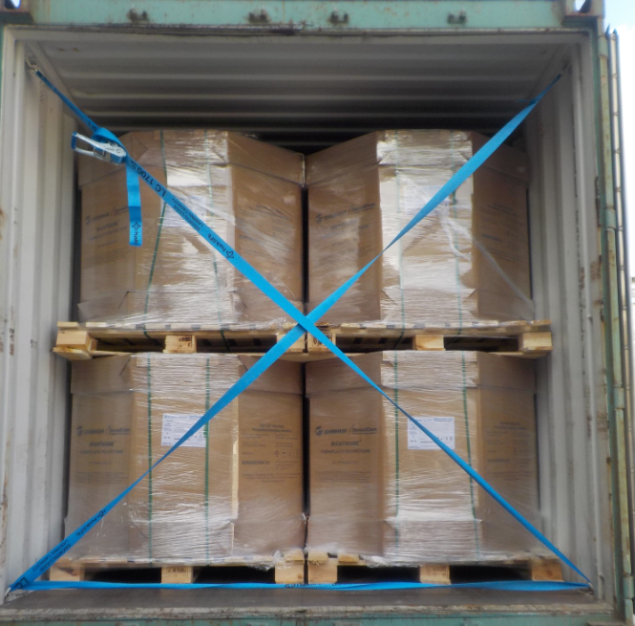

Filling conditions, requirements for chlor-alkali products

Filling into tanker/tank container
The means of transport must be suitable for the transport, the product to be transported must be loaded and it must comply with the relevant legislation and quality parameters.
The tanks, dome cover, fittings must be clean and intact. The filling station reserves the right to refuse to fill the means of transport if the condition of the tank or the vehicle is unsatisfactory.
The tanks must be cleaned with an official washer and the cleaning must be certified by an ECD (EFTCO cleaning document). Products can be filled into a clean or dedicated tanker/tank container. If the tanker/container has been transported after the last washing, the last washing document must be accompanied by a declaration of cleanliness (signing) issued by the carrier/customer. In the cleanliness declaration, the carrier/customer certifies that only the product in question has been loaded into the tanker/container since the last cleaning.
If the driver is unable to produce a recent wash or previous wash + clean (dedication) declaration, the operator will refuse the filling.
In the case of FCA transport, the competent sales organisation will send to Chlor-alkali Loading, prior to the shipment, a declaration completed by the customer certifying that the tanker/container is suitable for the material to be transported.
The product can be loaded at the predefined time. Failure to do so will result in the carrier having to rebook the loading for the next time-slot.

Filling of chlor-alkali products
It is checked by the operator before filling:
- the transferred documents
- the degree of filling
- the compliance of the tanker/tank container with ADR and its labelling
It is mandatory for the operator to check that the means of transport arriving for loading has weighed the initial weighing on the automatic weighing equipment and that the tare weight is sufficient for loading/filling. If the initial weighing is not met, the truck must be sent back for weighing.

The driver is involved in the filling of chlor-alkali products as follows
- The driver of the vehicle arriving for loading stops in the parking lot of the Chlor-alkali Loading station. The GPS coordinates of the parking lot can be found on the Loading order.
- The driver shall check in with the filling operator for road transport at the operator's containers in the room designated for that purpose. The operator receives the loading order, the cleaning wash + clean documents and the driver's access card. The operator checks in with the access card, opens the YMS (Yard Management System) tab for the specific shipment, where he documents the filling.
- In the case of a multi-compartment tanker, the driver determines which compartments to load the quantity to be transported and how to distribute it.
- The driver must then drive the vehicle to the filling point designated by the filling point staff, as instructed. Accurate positioning of vehicle is assisted by filling point staff from the filling bridge.
- The driver shall stop the vehicle and then leave the vehicle wearing protective equipment and carry the gas mask with him.
- Before starting the filling operation, the driver must wedge the vehicle and check that the discharge fittings are closed.
- The driver then leaves to his/her designated driver's lounge. During filling, the driver is not allowed to stay in the filling point area, to enter the driver's cab, to start the vehicle, to remove wedges or to climb onto the filling bridge!
- The tanker/tank-container is filled through a dome lid. The filling line and, in the case of hydrochloric acid, the gas equalizing line, are inserted into the filling opening by the filling point operator.
- The driver must wait in a designated driver's lounge during the filling process.
- The filling of the tanker/tank-container is considered complete when the filling operator has removed the filling pipe/gas equalizing line, closed the dome cover, washed the tank with a water jet and raised the tipping step.
- When filling a multi-compartment tank-vehicle, after the first compartment has been filled, the operator disconnects the filling pipe, pulls up the tipping step and informs the driver. The driver removes the wedges and then moves the tanker to the next chamber with the filling opening under the filling pipe. The driver stops the vehicle, wedges the vehicle and leaves again to the driver's lounge. This operation is repeated as many times as the number of chambers to be filled.
- At the end of the filling operation, the filling station staff will document the release of the product and hand over the necessary documents to the driver.
- After the filling is completed, when the operator is authorised to leave the filling station, the driver must remove the wedges from under the vehicle combination and leave the filling station area.

Requirements for drivers:
- For safety reasons, effective communication with the filling station staff is essential.
- Have the necessary personal protective equipment required at the filling point. The operator's container can be approached from the parking lot on the so-called "green road", the driver does not need to wear a helmet or safety goggles to check in. The filling station is a technological area, when leaving the vehicle, the driver must already be wearing the required protective equipment: helmet with chinstrap, safety goggles, closed protective clothing (flame retardant, antistatic, chemical resistant) and protective footwear and a full face mask with filter cartridge, with ABEK-CO-NO-Hg-P3 combined filter cartridge.
- If the driver is not wearing the required personal protective equipment, the filling station will refuse to fill the tank.
- Appearance in working order. In order to avoid an accident, no loading/unloading should take place if it is obvious that the driver is: under the influence of alcohol, drugs or narcotics.
- Safe and responsible behaviour.
- As with most companies, BorsodChem Zrt. has internal rules designed to protect the safety of employees and visitors, and these rules must be followed.
  - Follow the procedures and warning signs in place.
  - Observe the maximum speed limits.
  - Follow the routes described.

Follow the instructions of the company/location staff.

1.2.8 Filling/loading POLYOL BLENDS
POLYOL BLENDS are delivered from Loading MDI area.
The bulk filling of POLYOL BLENDS is carried out in a closed system similar to isocyanates. During filling, the product connections have diameters of DN 50/80 whereas the gas connections have diameters of DN 25/50. The connecting flexible hoses are equipped with quick couplings.
For product delivery, the driver must report to the foreman's office. The foreman or shift manager manages the filling and loading operations.
The driver must heat the tank according to the type of material to be filled:
- For POLYOL BLEND min. 45°C max. 50°C

The finished product can be loaded into a tank truck, barrel, or 1 m ³ IBC container according to the customer's requirements.
Before filling begins, the filling station staff inspects the followings:
Upon check-in, the operating personnel must check whether the transport vehicle arriving for loading has passed the initial weighing on the automatic scale and whether the tare weight is appropriate for loading/filling. If the initial weighing has not been completed, the truck must be returned for weighing.

1.2.8.1 The driver participates in the filling of POLYOL BLENDS as detailed below.
- The driver should park in the designated parking lot, wear the required protective equipment, report to the foreman for loading and hand over the "Loading Order".
- If he has received instructions from the filling station operator, drive the vehicle assembly to the designated filling station. If a mobile STOP sign is placed in front of the filling station, you may only drive to the filling station after the sign has been removed! The filling station operator is responsible for handling the mobile STOP sign. The mobile STOP sign is returned during filling. The filling station operator must clearly indicate to the driver that the sign has been removed.
- When starting to fill, the driver must stop the trailer truck of the vehicle assembly at the filling point, ground the vehicle assembly, secure and wedge it against any movement.
- The driver then performs the following operations to connect the tanker/tank container:
  - When connecting and disconnecting, it is mandatory to wear protective overalls, which must be worn over and together with the work clothes.
  - First, the gas line is connected to the transport device, then by opening the gas branch fittings, a common air space is created between the gas spaces of the tanker/tank container and the product storage tanks. This operation must always be performed first, because this ensures that the nitrogen remaining in the tanker/tank container during the previous unloading is released towards the MDI storage tanks. After performing this operation, the gas branch fittings must remain open for the pressure test to be performed before starting the filling and certainly during the filling. It is FORBIDDEN to remove the closing element from the siphon pipe of a transport vehicle under nitrogen pressure!
  - Only after releasing the nitrogen pressure can the closing element be removed from the liquid branch! The transport vehicle can be connected by means of using quick connectors if the transport vehicle has the appropriate counterparts, or flange joints in default of these.
  - The driver is allowed to perform the connection only with intact seals specified for POLYOL BLENDS (Teflon). The driver must have seals required for the tank truck/tank container connections .
  - Quick connectors and flange joints must be connected with adequate compactness. Any problems emerge with the seal or the connection must be reported immediately to the operator/supervisor, who will arrange for troubleshooting. No leaks may occur during filling, which must be checked with a nitrogen pressure test after connection and before starting to fill!
  - If the driver steps out of the area outside the guardrail installed on the loading bridge or has to raise the guardrail installed on the tanker, the fall arrest system installed must be used. Failure to do so it is PROHIBITED to perform any activities or moving around in these parts of the tanker!
  - After equalizing the pressure, check the compactness of the connection with 3 bar nitrogen. Open the manual nitrogen fitting built into the filling line, the closing fitting mounted on the siphon pipe is closed. If the connection is tight, close the manual nitrogen fitting, open the closing fitting mounted on the siphon pipe of the tanker/tank container. Afterwards, make sure the siphon pipe is penetrable, which must always be done before starting the filling!
  - The filling station operator checks the pressure test and the patency of the siphon pipe. If patency is confirmed, close the DN20 manual assembly.
  - If the vehicle assembly has been connected, the pressure test has been performed and it is satisfactory and the siphon pipe is passable, the driver reports the vehicle's final fitting. The filling station operator begins filling the tanker/tank container.
  - After starting the filling, the driver checks the compactness of the system. Any leaks detected are reported to the Loading staff. In such a case, the filling must be stopped immediately and the fault must be eliminated at once.
- In order to minimize the release of POLYOL BLEND vapours into the atmosphere and to avoid leaks, the filling nozzle must be blown through for a few minutes with 3 bar nitrogen built into the filling line towards the transport vehicle before disconnecting the connections. After closing the fittings, the driver must disconnect the tanker/tank container from the filling station and the appropriate closing flanges must be installed on the tanker/tank container, as well as on the filling and gasification nozzles.
- The driver must be given the number of service locks required.
- All domes of the space used for transportation must be locked with the plant lock issued by the plant.
- The driver must remove the chocks from under the vehicle assembly and disconnect the grounding cable from the vehicle assembly.
- After the filling is complete, the filling station staff will hand over the necessary documents to the driver. If he has received permission from the filling station staff to drive off or if the mobile STOP sign has been removed, he may drive off the scale. The filling station operator must clearly indicate to the driver that the sign has been removed as the sign is not visible from the cab or it is detectable only with difficulty.
- The transport vehicle may leave the Loading area.

1.2.8.2 POLYOL BLENDS loading
- Before loading is started, the loading site checks whether the transport vehicle has protection against longitudinal movement of the load. If the transport vehicle does not have such protection, loading cannot be started.
- Once loading is complete, the fixing of the shipment is documented in a photograph taken by the loading site operators.
- The quantity and quality of fixing devices must be available for the design of the transport vehicle and the load.
- The driver must fix the load in such a way that it cannot move during transport.
- The distribution of the load on the vehicle is carried out by the forklift driver according to the driver's instructions. From then on, the driver is responsible for the safe arrangement and fixing of the load, which he confirms by signing upon receipt of the load.
- The Packing List documents may only be handed over to the driver after the cargo has been fixed. In case of unfixed or improper fixing, the delivery of the Packing List documents shall be refused until proper fixing has been completed.

Documentation

Gross weight weighing
Gross weight weighing is always performed at the automatic weighing equipment at Gate IV and Gate 41 (see map)
When weighing, follow the instructions on the terminal of the weighing equipment!
In case the total weight of the transport vehicle exceeds the maximum weight allowed by the applicable legislation, the Forwarding Agent will refuse to prepare the documents and will take measures to solve the problem with the involvement of the partner departments.

Documentation
After a successful Gross weight weighing, the transport vehicle must be parked in the internal vehicle parking area (see map) at Gate IV and Gate 41. The gross weight is checked at the Forwarding Department. The driver must report to the Forwarding Office (see map) with the documents received at the plant and the automatic weighing slip.
Forwarding staff will prepare the set of documents to accompany the shipment.
The SDS data sheet is provided to the carrier by his principal. If the BC is the freight forwarder, the SDS data sheet for the goods to be transported was attached to the request for quotation, so the Forwarder is not obliged to give it to the driver!

Customs clearance
If the consignment needs to be cleared through customs, the customs clearance is done by the Forwarding Office. Customs clearance is carried out by the Forwarding Office in its own right 24 hours a day. In all cases, the transport vehicle is sealed with customs seal by a Forwarding Agent.

Gate exit (at gates 4 and 41)
The delivery note issued by the Forwarding Office is checked by the Passenger and freight administrator when leaving the gate.
It must be indicated on the delivery note:
- product name
- SZU number
- weight
- plant lock/ ship lock
- container number
- type of loading
- driver's name, vehicle license plate/registration number
- signature and stamp of the plant and the driver.

Electronic delivery note control
- scanning of a delivery note or guest card
- reconciliation of the data displayed in the electronic delivery note programme with the data on the delivery note
- delivery note number, SZU number, name, license plate/registration number, plant lock, container number (if any), weight.

Weight check
The weight on the delivery note must correspond to the weight on the attached weighing slip or packing list. When checking the weight on the delivery note and on the weighing slip, account must be taken of the margin of tolerance allowed in each case. If there is a discrepancy greater than the permissible deviation, the consignment is returned to the loading area and, in the case of a shipment of parcels, the cargo is checked by opening the loading area of the vehicle.

Checking the vehicle
The clerk will check the license plate/registration number of the vehicle against the delivery note, the visible plant locks and other storage compartments. After check-out, the driver hands the guest card to the administrator and leaves.
If the vehicle has not been loaded, the dispatching plant must keep a report of the reason why it has not been loaded (e.g. contaminated storage area). The report must be accompanied by the weighing slip certifying that the vehicle is empty.

General HSE rules

General safety requirements
Smoking, use of open flame is FORBIDDEN in the whole area of BorsodChem and in the driver's cabs of vehicles! Electric cigarettes are also prohibited!
The transport company is obliged to comply with the BC safety regulations for its own employees and subcontractors!
BorsodChem stores toxic gases at all three of its production sites, so it is mandatory to have a gas mask with a filter insert ready!
The transport company’s employee must not enter areas outside the loading area. The driver must take the shortest possible route to the loading area.
It is FORBIDDEN to block traffic routes, stairs, fire hydrants, to open fire hydrant cabinets, to use fire extinguishing equipment for any purpose other than firefighting and emergency response.

It is forbidden to bring into the territory of BorsodChem Zrt. alcoholic beverages, substances classified as narcotic drugs or narcotic substances, or to consume them on the company's premises. It is prohibited to admit, employ or have on BC premises any person with detectable levels of alcohol or under the influence of alcohol, narcotic drugs or narcotic substances.
Any employee under the influence of the above substances will be banned from the territory of BorsodChem.
Transport companies may only bring in and use machinery and equipment which meet the requirements laid down in the safety regulations and may only use working methods and technological procedures which ensure safe working conditions that do not endanger health.
The provision of protective equipment is the responsibility of the transport companies!
Subcontractors must have special protective equipment and clothing specified for the transport company. The transport company is responsible for ensuring that protective clothing and equipment is available and that it is used for its intended purpose. Failure to do so will result in the transport company being liable for any failed loading and/or transport.

Vehicle traffic, transport of materials
Vehicles are only allowed to use the designated route and park in the designated parking area.
The partial or complete blocking or closure of traffic routes by motor vehicles for parking, waiting or stopping purposes is prohibited, even temporarily!
In the event of a broken-down vehicle that is unroadworthy, the loading area staff or the Forwarding Office or the Gate staff must be informed immediately and who shall inform the Dispatcher.
Vehicles travelling on the territory of BorsodChem are only allowed to use the roads and must always take the shortest route to their destination.
The speed limit in BC is 30 km/h, except where otherwise indicated on the traffic sign.
In the case of loading activities, the place where vehicles stop or wait must be chosen so as not to obstruct traffic or the parade of fire brigades.
Only vehicles which comply with the relevant technical and safety regulations and which do not pose a fire or explosion hazard when used in accordance with the technical and safety regulations and for their intended purpose may be used for transport.
The driver of the vehicle is responsible for complying with the fire safety regulations applicable to the vehicle.
Flammable liquids and gases may only be transported in a sealed container (bottle, can, drum) that is free from defects and complies with the relevant regulations.
Flammable liquids, flammable and explosive substances may only be transported and stored on the premises of BorsodChem in accordance with the relevant regulations.

Characteristics and occurrence of hazardous substances in industrial quantities in BC premises
AMMONIA
Colourless gas, smells pungent, irritating. Liquid ammonia quickly turns into a gas, forming a cold mist with the air, which is corrosive and explosive.
Occurrence sites: Ammonia and Nitric Acid Plant, MDI Production, TDI Production.
CARBON MONOXIDE
Colourless, odourless, toxic, flammable gas. Inhalation of the gas inhibits blood oxygen uptake, causing death by suffocation.
Occurrence sites: Ammonia and Nitric Acid Plant, MDI Production, TDI Production.
PHOSGENE
It is a colourless, highly toxic, non-flammable gas with an odour reminiscent of unripe grain. Inhaling the gas is particularly damaging to the lungs. In larger quantities, it can cause death. Symptoms may appear a few hours after the exposition.
Occurrence sites: MDI Production, TDI Production.
CHLORINE
Yellowish green in colour, with a characteristic pungent odour, highly corrosive and toxic. In case of the gas is inhaled, it causes respiratory spasms and, in high concentrations, suffocation.
Occurrence sites: Chlorine Plant, MDI Production, TDI Production, DKE/VCM Plant, Hydrochloric acid decomposition Plant.
HYDROCHLORIC ACID GAS
A pungent smelling, colourless gas. Inhalation of high concentrations causes etching injury on the mucous membranes of the nose and throat, laryngospasm, death.
Occurrence sites: Chlorine Plant, MDI Production, TDI Production, DKE/VCM Plant, Hydrochloric acid decomposition Plant.
VINYLCHLORIDE
A sweet-smelling, colourless gas. The gas has a narcotic effect and irritates the airways. The rapid evaporation causes the oxygen in the air to be displaced. Hydrochloric acid gas is formed during combustion.
Occurrence sites: DKE/VCM Plant, PVC Plant.
DICHLORETHANE
It is a colourless, oily, flammable liquid with a similar odour to chloroform, its vapour ignites easily and when mixed with air it forms an explosive mixture. Its vapour is intoxicating in higher concentrations.
Occurrence sites: DKE/VCM Plant.
ORTHO-DICHLOROBENZENE (ODCB)
Oily, pungent smelling, flammable liquid. Its vapour has an intoxicating effect, strongly irritating the eyes, respiratory tract and skin. Its fumes spread along the ground, ignited by hot surfaces, sparks, open flames.
Occurrence sites: MDI Production, TDI Production, DNT Plant.
FORMALIN
A pungent smelling, highly irritating, colourless, flammable liquid. Hot surfaces, sparks, open flames will ignite it. Its vapour is very irritating to the eyes and respiratory tract.
Occurrence sites: MDI Production.
ANILINE
Oily, brownish liquid with a characteristic odour, toxic, flammable. A strong blood poison, absorbed through the skin.
Occurrence sites: MDI Production.
TOLUENE
It is a flammable liquid; its vapour ignites easily. The liquid evaporates easily, and its vapour forms an explosive mixture with air, which has a higher density than air. Ignited by a hot surface, spark or open flame. Its vapour is narcotic in high concentrations and irritating to the eyes and respiratory tracts. The liquid can be absorbed through the skin.
Occurrence site: DNT Plant
NITRIC ACID
It has a strong corrosive effect on the whole organism. Nitric oxide compounds are formed on its decomposition. The corrosive gases and vapours produced irritate the eyes, respiratory tract and lungs. Inhaling nitric acid or NOx gases can cause chest pain, eye inflammation and breathing problems. Their damaging effects are visible on the eyeball and teeth.
Occurrence sites: Ammonia and Nitric Acid Plant, DNT Plant.
NITROUS GASES
Reddish brown, pungent smell, poisonous, gas, soluble in water. The substance is irritating/disturbing to the eyes and respiratory system. Inhalation of the substance may cause pulmonary oedema. Inhalation may cause abdominal pain, coughing, headache, drowsiness, burning sensation, nausea, dizziness, confusion. Symptoms may appear with a delay.
Occurrence sites: Ammonia and nitric acid plant, DNT Plant

Regulations in case of emergencies
In the event of sirens or other signals indicating danger, the area must be left in a direction perpendicular to the wind direction after the activity has stopped, using the gas mask kept ready, and after the loading area has been brought to a safe state (electrical equipment disconnected, etc.). The wind direction is indicated by windsocks.
The transport vehicle must be stopped and securely locked and the employees of the transport companies must move to the designated assembly points (gates, designated lounges)
In the event of a gas leak, proceed as directed by BC employees.
Fire alarm, emergency alarm:
Any fire or emergency detected should be reported immediately to BC staff.
Behaviour in case of fire: All transport workers are obliged to start fire-fighting and life-saving operations with the means available to them and in the manner they are expected to use.
All transport workers are obliged to participate in fire-fighting, life-saving and property-saving when called upon to do so. In firefighting, the instructions of the fire chief and in rescue operations, the instructions of the rescue chief must be fully carried out. People who are not involved in the rescue work should not be unauthorised at the scene of the fire, as their presence increases the risk of accidents and hinders the extinguishing of the fire. Failure to give a fire alarm or to take part in the fire-fighting, non-compliance with fire safety rules may result in a financial penalty (penalty fee).
In the event of a loading or transport incident, drivers must participate in the investigation of the incident and cooperate with the competent authorities.

Safety inspection
BorsodChem regularly inspects the loading of transport companies from a safety point of view.
The competent authorities in BC are authorised to carry out safety inspections of transport companies.
If, during an inspection of a transport company, the competent staff of the BC organisations carrying out the inspection find serious irregularities that endanger the safety, property or reputation of BC, they are entitled to suspend work immediately or, if necessary, prohibit it.
In the event of serious irregularities or infringements of rules, the offender must be removed from the premises and the penalties set out in the contract must be applied, which are enforced by BC as a penalty fee. Depending on the seriousness of the infringements of rules, the BC may initiate an administrative procedure.

Environmental protection regulations
During loading, the release of harmful substances into the environment should be prevented, but if this cannot be avoided, the release should be minimised. Let's protect our immediate environment and nature! This is the responsibility of each individual, and it is in their personal interest.
In the BC area, wastewater and rainwater are collected by different sewer systems and the collected water is then discharged to the receiving water after different treatment processes depending on the level of pollution and the quality of the pollutants. In order to ensure that the effluent generated leaves the BC area only after proper treatment and that the treatment process is not disturbed by a particular contaminant, it is necessary to comply with the relevant regulations.
BorsodChem has an Operational Damage Prevention Plan (hereinafter the Plan) in accordance with the legal requirements, which has been approved by the Environmental Protection Authority. Representatives of transport companies in BC premises may consult the Plan at the Environmental Protection Department or Dispatcher Service.
The Plan covers surface and groundwater, geological features, designated or protected wildlife species, breeding and resting places, natural habitats, Natura 2000 sites and their protection.
The washing of vehicles, tankers and tanks on the territory of BorsodChem is only allowed with a special permit.
In the event of an accident or other emergency where large quantities of pollutants have been/may be discharged into the sewer, the site manager or BC employee must be notified immediately.
If the material spilled during the damage event is the property of the loading company or material brought into BC by the loading company to perform its work, in addition to notification, the water quality damage must be remediated immediately.
BC pays particular attention to the protection of soil and groundwater. In addition to technical interventions, significant results can be achieved with attention, discipline and due diligence.
Do not discharge pollutants directly to the soil!
Efforts should be made to minimise the amount of material that is discharged. In all cases, the digestion and/or collection of spilled material shall be carried out as directed by the BC employee in charge of the plant or the filling station.
When filling on paved surfaces or in damage barriers, special attention should be paid to the preservation of the pavement.
Avoid damaging landscaped, grassed areas and public spaces. The person who caused the damage is liable to pay the cost of restoration.
During transport, the dispersal and leakage of cargo must be prevented. If this happens, the roads must be cleaned/cleared, which is the responsibility and cost of the transport company carrying out the transport.

Asset protection rules
At BC, the fundamental objective of asset protection is to prevent, interrupt and detect acts that damage BC property. It is important to use and increase the assets and other assets under BC's management in a planned, economical way. The priority is to enforce the general legislation on company law, work discipline and legality.
All persons leaving the BC premises must show the contents of their bag or baggage to the Passenger and freight administrator without being asked to do so. At the request of the administrator, he/she must enter the inspection room, facilitate the inspection and provide the requested information. The BC armed security guard has the right to search clothing if justified. The Passenger and freight administrator has the right to detain a person for the purpose of screening clothing in justified cases, pending the arrival of an armed BC security guard or a representative of the competent police authority.
If the inspector finds an object on the person leaving which may not be taken out of BC without a transport document, or if its ownership or origin is in doubt, the service shall detain it and take a record of it and forward it to the Guard and Security Department (GSD) for further action.
Due to the potentially high risk of fire and explosion associated with BC technology, and in order to protect the life and physical health of employees, no person shall be admitted to or remain on BC premises while under the influence of alcohol or drugs or intoxicants detectable in the body.

Employees of the Guard Security Department may carry out alcohol checks on drivers entering and leaving the gates, to which everyone is obliged to submit themselves. If alcohol is detected in the body of the person driving the vehicle, the gate service shall refuse entry or exit and, with the assistance of the Armed Security Guard, shall notify the competent territorial police service via the dispatching service and confiscate the access card of the person concerned.
If an alcohol check of the driver (e.g. during waiting, delivery of goods) on the Company's internal premises is positive, the Armed Security Guard will escort the driver off the Company's premises.
A blood alcohol test sample will only be taken if the person concerned is unable to blow out the certified breathalyser. The inspection must be carried out at the BC Surgery in the presence of a representative of the department carrying out the inspection.
In the case of a worker who has undergone a blood alcohol test and who has tested positive, the department carrying out the test will arrange for the reimbursement of the costs incurred in the context of a compensation procedure. If the result of the blood alcohol test is negative, the cost will be charged to BC.
If the employee refuses to submit to a breathalyser test or to sign the report, this will be considered a breach of the rules and the rules on persons under the influence of alcohol will be enforced against them.
Against transport companies who violate this rule will be subject to prosecution or expulsion from BC under the BC-EHS-215 Sanctions Policy.
During the inspection of materials and goods, the inspection service may randomly move some vehicles aside and inspect their load more thoroughly than usual, and, if necessary, unload the load for inspection.
In relation to the receipt of materials entering BC territory, the Passenger and freight administrator must handle the delivery document if the crew of the transport company's vehicle has expressly requested it, or if it has brought in material that is not unloaded on BC territory but is being returned, and in all cases where BC so orders.

Road traffic regulations in BC
On the internal and external routes of BorsodChem, primarily but not exclusively the rules of the Highway Code apply. The Guard and Security Department is responsible for the establishment and enforcement of road traffic regulations in the BC area. Driver can drive a motor vehicle with a valid driving licence for the relevant category, with a valid driving permission and a valid technical inspection of vehicle. When the vehicle is inside the BC area, the name (logo) of the operator, the name of the driver and the mobile phone number must be displayed. Travel in BC is only allowed on designated routes. Pedestrians must use the pedestrian walkway in the BC area. If there is no dedicated route for pedestrian traffic, the rules of the Highway Code apply.
Ignoring no-entry signs, mandatory stop signs, red lights at a railway crossing, ignoring a barrier and exceeding the speed limit - due to the high risk of fire and explosion in BC - are considered the most serious traffic offences. Access to areas protected by these signs, barriers and service roads is subject to special authorisation.
Transport companies entering BC premises will recognize the results of measurements taken with a certified speed measuring device in BC.
There are several water chillers in BC, which can create dangerous situations depending on the weather. The dense, foggy mist around them can limit visibility by up to 5-10 metres, and condensation on the road surface can cause a slip hazard. To avoid dangerous situations, the vehicle must be driven in such areas according to visibility and road conditions. Attention must be paid to the characteristics of the vehicle, its passengers and its load.
It is forbidden to drive on, park on, or drive over manhole covers or cable manholes in landscaped areas covered with crushed stone throughout BC. Parking is only allowed in designated areas. It is forbidden to leave the vehicle in such a way that it can be used by an unauthorised person.
The partial or total blocking or closing of traffic routes by motor vehicles for parking, waiting or stopping purposes is ALWAYS PROHIBITED!
The vehicle registration document and driving licence must be carried by the driver while driving.

Rules on security of property
In the case of offences against property committed against transport companies, the head of the transport company is entitled to file a police report, which must be notified in advance to the Guard Security Department.

Sanctions table
https://borsodchem.com/biztonsag-mindenekelott

Annex 1 SKETCH MAP OF BC



