Dear Visitor,

Welcome on BorsodChem site.

By virtue of this information let us call your attention to some basic rules serving your and our Company’s safety.

- Persons arriving at the Company site with a purpose to pay a visit are allowed to enter in the shortest way to the area designated in the entrance permit.
- Any abuse with the entrance card – including the assignment or unlawful use of card – will result in the long-term withdrawal of the entrance permit.
- It is FORBIDDEN to enter BC site under the influence of alcohol or bring in any beverage containing alcohol!
- Vehicle drivers arriving for product delivery shall have the appropriate personal protective equipment and in default thereof their entrance is not permitted.
- To prevent soil contamination only vehicles in proper technical state are allowed to enter BC site. Neither petrol nor lubricant dripping is permitted!
- Visitors entering the Company site are obliged to use the hard hat equipped with a chin strap and safety goggles ensured for them in the technological area and keep the gas mask standby.
- In case of sounding the alarm siren all vehicle drivers shall immediately stop in a way so as not to block the road there, stop the engine, put on the gas mask kept in standby and leave the endangered area at once. The route shall be selected vertically to the prevailing wind direction.
- Smoking is FORBIDDEN on the entire BC site and also in the cabin and passenger compartment of vehicles!
- Regulations of the HIGHWAY CODE are effective primarily but not exclusively on BorsodChem site. The allowable maximum speed of vehicles on the Company site is 30 km/hour.
- The security service performs continuous inspections by means of calibrated tachometer on the plant site.
- Any non-observance of a no entry road sign or a railing bar closing down a technology area shall qualify as the most severe traffic offence. Entry

into the protected area of plants is enabled only in the possession of a written permit issued by the plant.
- It is FORRBIDDEN to drive and wait on the parked areas on the entire BC site, drive over a sewer cover or cable shaft as well as park within 3 m range of a fire hydrant by a vehicle! Parking is permitted only in the designated areas!
- Mobile phones can be used in the technological -, storage - and loading/unloading areas of plants only with the permission of the manager competent by field in the area designated by him.
- Recording any picture – and voice by own devices brought legally to the Company site is allowed only with a written permission.
- It is strictly forbidden on public media to share and distribute pictures and voice recordings, other data and information recorded on BorsodChem site with permission!
- Any information obtained in terms of our Company’s operations shall qualify as a trade secret, which cannot be handed over to a third party without BC’s permission and they can be used only for the activity related to the purpose of visit.
- The persons who fail to observe the above regulations will be banned from our Company site and will be refused to drive on BC site. In a more severe case, BorsodChem Zrt. will initiate authority charges against them.
- Several water-cooling devices are operated on BC site, a dense and fog-type vapour may develop around them, which may restrict visibility even down to 5-10 meters or the vapour condensed on the road surface may cause slippery risk.

EHS Management

Coordinates at BorsodChem Zrt.’s Gate 4:

Northern width: 48.246358
Eastern length: 20.659530

Reporting accident, fire and emergency (BorsodChem dispatcher center):

+36-30-671-1515

Personal protective equipment is obligatory for carriers who arrive at the areas of filling and loading plants.

Minimum requirements:

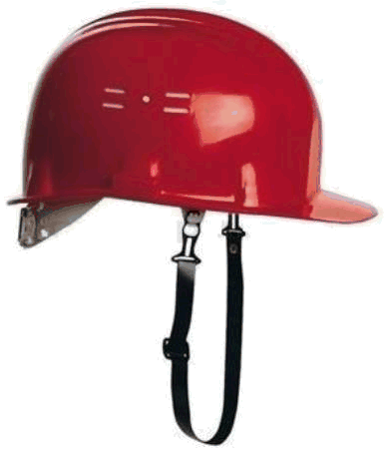
- Hard hat with a chin strap
- Safety googles
- Safety gloves
- Safety shoes / boots
- Closed protective clothing
- Breathing guard /gas mask
- ABEKCONOHgP3 filter canister

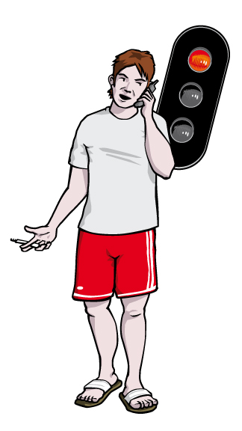
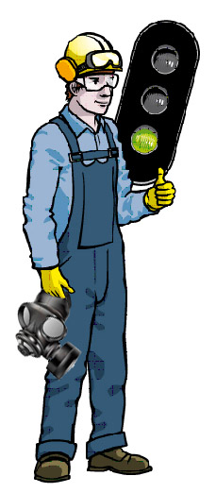



INFORMATION

